Name:________________________ Date:________

Proving the Pythagorean Theorem

Goals:
Students will prove the Pythagorean Theorem by finding the area of the sides of a right triangle.

Students will discover that the area of the hypotenuse is equal to the sum of the areas of the two legs.

Objective:
Given “Proving The Pythagorean Theorem,” the students will work in groups to determine the area of the sides of a right triangle for three consecutive trials.

Terms to Know:

Right Triangle: a triangle with a right angle (90 degrees).
Hypotenuse: the longest side of a right triangle, opposite the right angle.
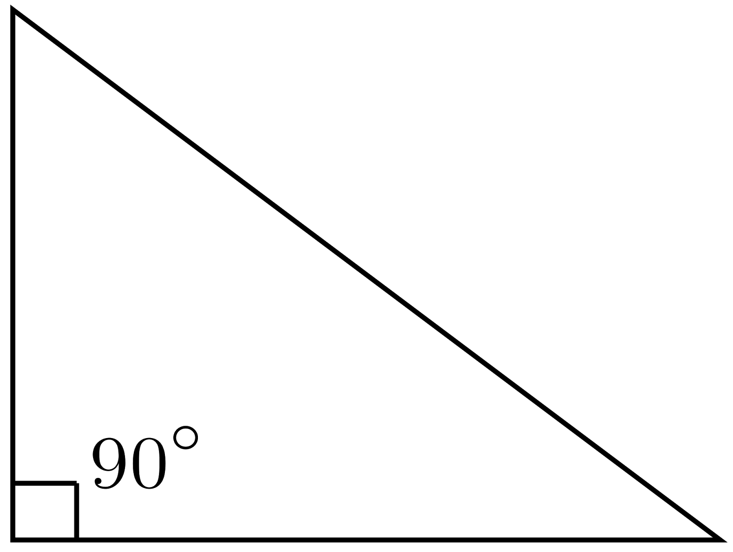
Leg: either of the two shorter sides of a right triangle.

The Pythagorean Theorem:
- When a triangle has a right angle (90 degrees) and squares are made on each of the three sides...then the biggest square has the exact same area as the other two squares put together!
- The equation: $a^{2}+b^{2}=c^{2}$
- Note:
  - c is the longest side of the triangle (hypotenuse)
  - a and b are the legs
  - The area of a square is: $A=a^{2}$

Question: Does $3^{2}+4^{2}=5^{2}$?

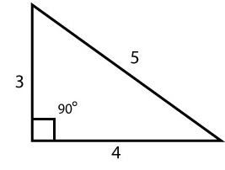

Proving the Pythagorean Theorem:

First Triangle:

- Determine which side is the hypotenuse and which sides are the legs.
- Line the starbursts along each side. How many starbursts did you use for each side?
- Create a square on each side of the triangle.
- Calculate the area of each square.
- Do the legs add up to equal the hypotenuse?
Second Triangle:
- Determine which side is the hypotenuse and which sides are the legs.
- Line the starbursts along each side. How many starbursts did you use for each side?
- Create a square on each side of the triangle.
- Calculate the area of each square.
- Do the legs add up to equal the hypotenuse?

Third Triangle:
- Determine which side is the hypotenuse and which sides are the legs.
- Line the starbursts along each side. How many starbursts did you use for each side?
- Create a square on each side of the triangle.
- Calculate the area of each square.
- Do the legs add up to equal the hypotenuse?

