Dilations with Polygons

What is a dilation?
Dilation: is a transformation that produces an image that is the same shape as the original, but is a different size.
- It can either stretch or shrink the original figure.
- Dilations use a scale factor
- Dilations are usually done using the center as the origin, unless said otherwise.

Example of Dilations:
- Perform a dilation with a scale factor of 3 on point A (2, 1)
  - in order to do so, we must multiply both the x and y coordinate by 3
  - A (2 * 3, 1 * 3) = A’ (6, 3)
- Perform a dilation of 1/3 on point B (2,4)
-B (2 * 1/3, 4 * 1/3) = B’ (2/3, 4/3)

- Given triangle ABC, dilate the figure by a scale factor of ½ using the center of dilation of (2,4).
-A(-8,2) B(-2,2) C(-4,-4)

-When we are given a center that is not at the origin, we have to do more than just multiply using the scale factor. Let’s take a look at these graphs:
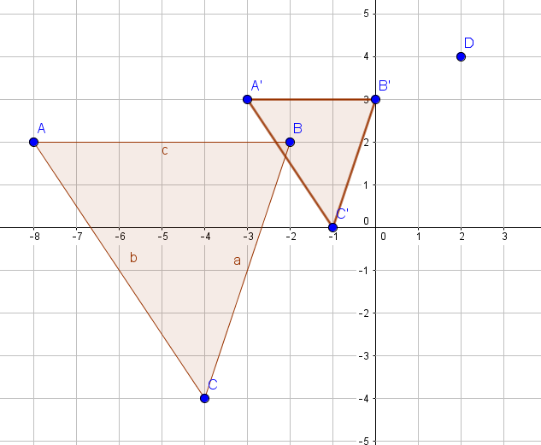
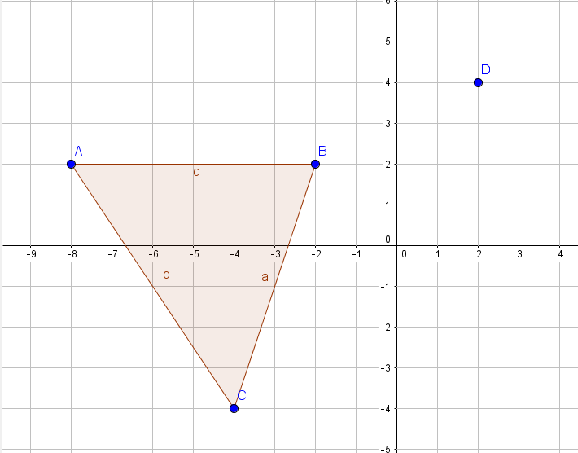
How did we get our new points,
A’ (-3, 3)
B’ (0, -3)
C’ (-1, 0) ?

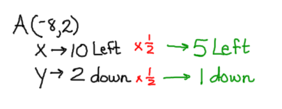
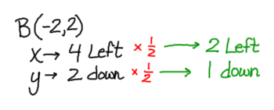
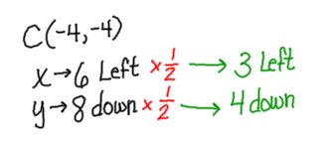

Performing Dilations on Geogebra:

Example: Perform a dilation with a scale factor of 2 on quadrilateral ABCD
A (2, 2.5) B (5, 5) C (7, 2) D (4, -1)

- Open up geogebra. If you do not have the axis on, right click and select “axis.”
- Start graphing the polygon ABCD  - Click the “point” block | 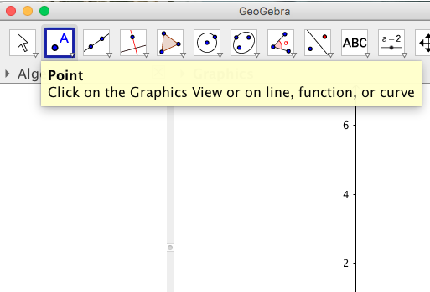
- Plot point A (2, 2.5) by locating it on the graph. Click down once you think you found it. If you click and you are not on (2, 2.5), move the point around by holding down the point and release once you get to (2, 2.5). You can make sure you are at the right point by looking on the left-hand side.  - Plot points B, C, and D. | 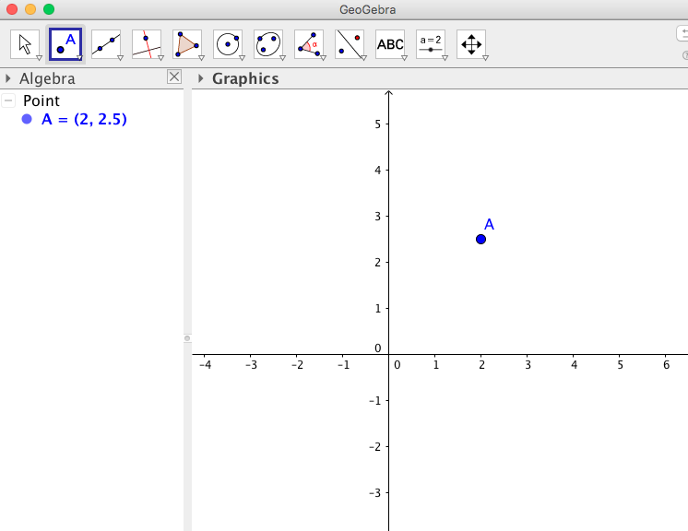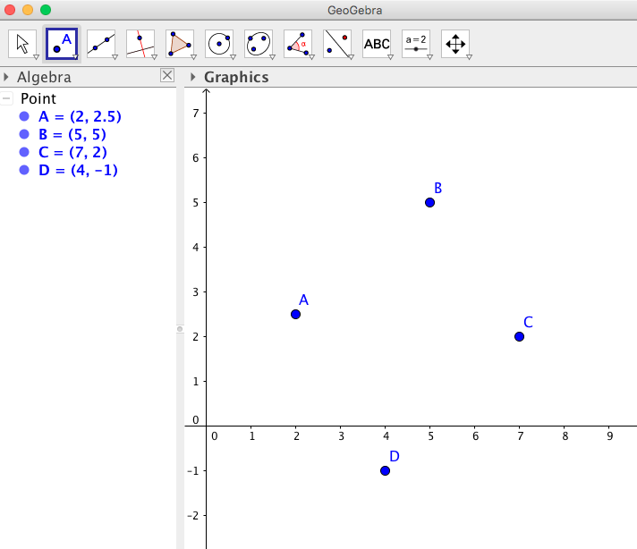
- To connect the points to make a polygon, click the “polygon” block. | 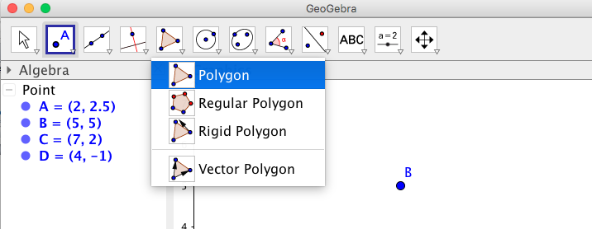
- Once it is selected, click point A, then B, C, D, then A again.  You now have the polygon ABCD created! | 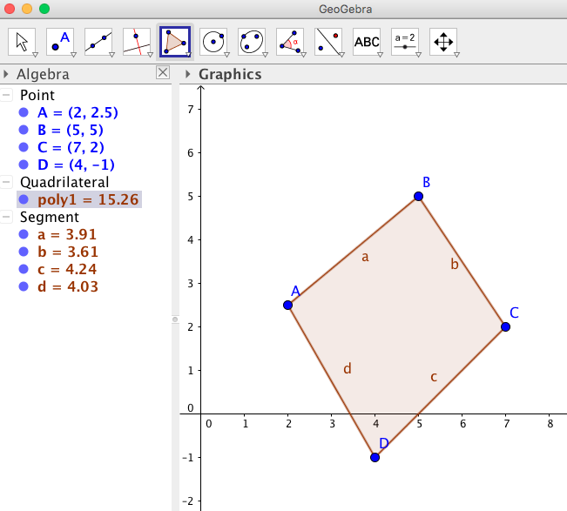
- Let’s do the dilation. Place a point at (0,0). This will become point E. | 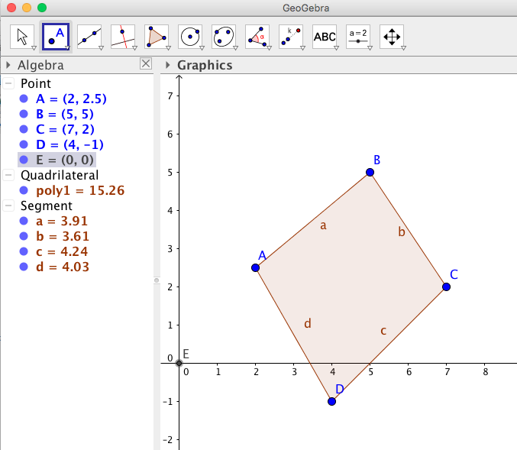
- To start our dilation, click on the “dilate from point” block. Then, click on the polygon, and then on the point E. A box should come up asking for the factor (the scale factor). Enter in “2” for the scale factor.  You should have a new polygon named “poly1”  with coordinates A’B’C’D’ | 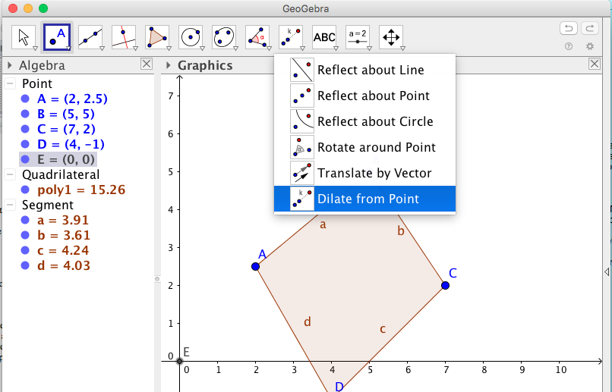  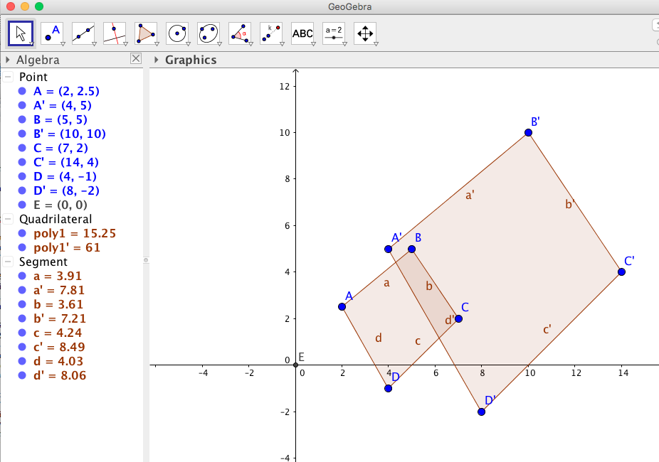
As we know, if a polygon is being dilated by a scale factor of 2, then the (x, y) coordinates of each point are being multiplied by 2.

Our new points should be:
    - A’ (4, 5)
    - B’ (10, 10)
    - C’ (14, 4)
    - D’ (8, -2)

Let’s try one when the center is not the origin.

Dilate the figure ABCD by 4/3 with the center at (0, -4).
A (-6, 3) B (3, 3) C (3, 0) D (0,0)
- Start a new document. Plot the points A, B, C, and D. Make it a polygon. | 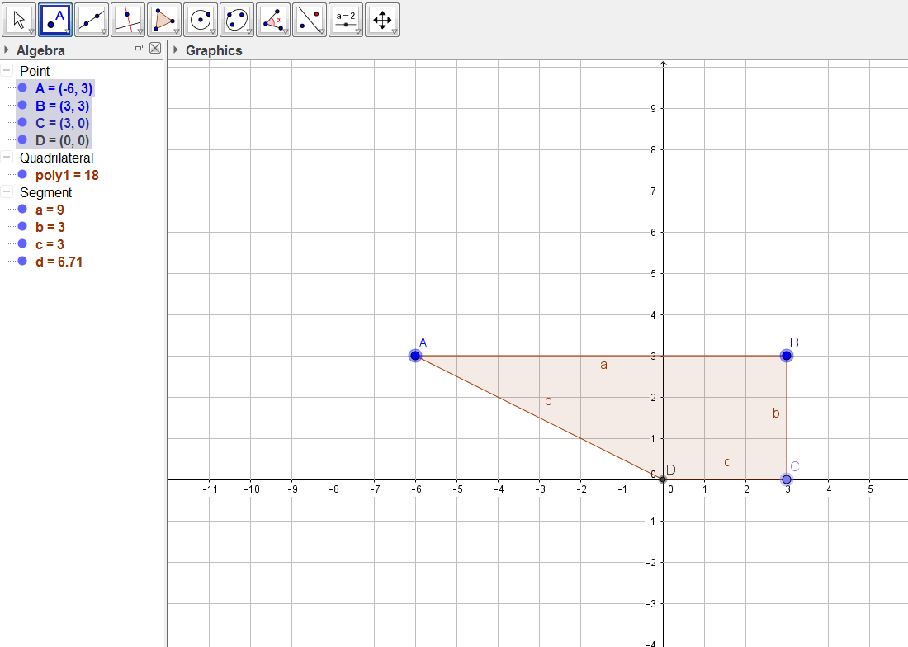
- Place a point at (0, -4). This will become point E. | 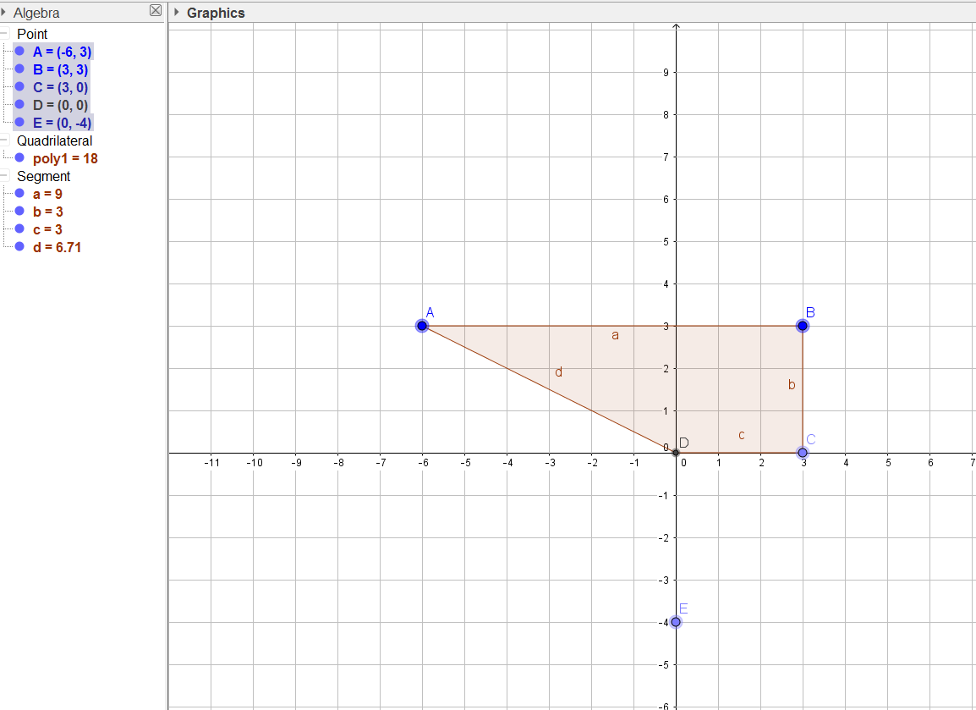
- Use the “Dilate from Point” block. Click on the polygon, then point E. Enter “4/3” for the scale factor.  Your new polygon should be labeled poly1’ and have the coordinates:  A’ (-8, 5.33)  B’ (4, 5.33)  C’ (4, 1.33)  D’ (0,1.33)  Verify together that our new polygon is correct. | 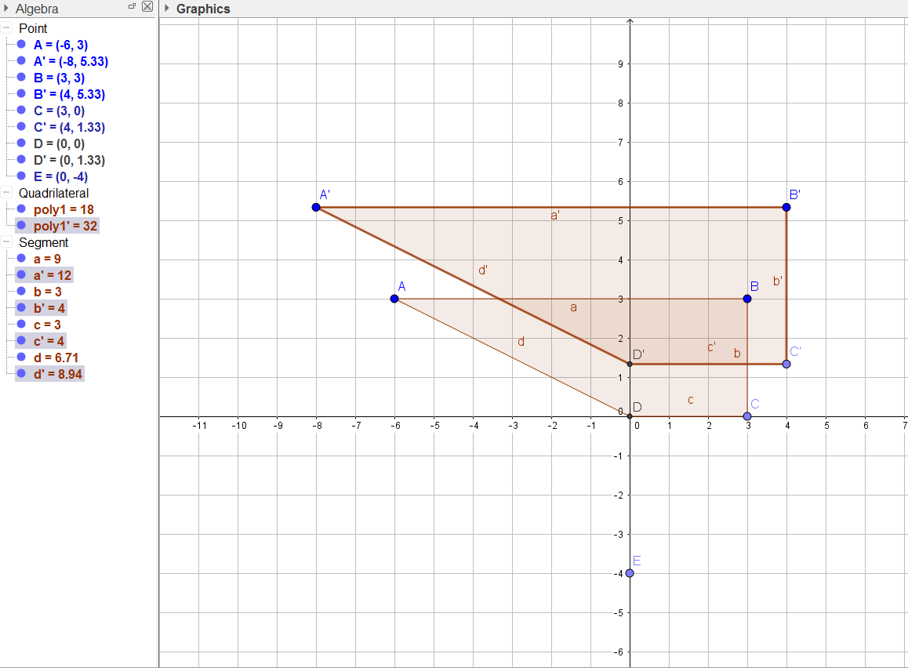

Resources

Saucier, Amy. “Dilations- When the Center is not the Origin,” Wordpress. N.p., Aug. 2014.
Web.

"Dilations in Math." Dilations in math. How to perform a dilation -Formula and Interactive
Demo and Practice Problems. N.p., n.d. Web.

